|  |  |  |  |  |  |  |  |  |  |
| --- | --- | --- | --- | --- | --- | --- | --- | --- | --- |
| Warmup Step | | 50 | | 60 | | 70 | | 80 | |
| Target_name | | CPU | Traffic | CPU | Traffic | CPU | Traffic | CPU | Traffic |
| Tier1 | UnderProvisioning Count | 54 | 42 | 74 | 40 | 84 | 42 | 110 | 127 |
| Overprovisioning Count | 66 | 66 | 48 | 64 | 37 | 55 | 0 | 4 |
| Underprov. # threshold based | 42 | 46 | 42 | 46 | 42 | 46 | 42 | 46 |
| Overprov. # threshold based | 52 | 51 | 52 | 51 | 52 | 51 | 52 | 51 |
| Tier2 | UnderProvisioning Count | 39 | 35 | 47 | 44 | 34 | 54 | 97 | 160 |
| Overprovisioning Count | 56 | 68 | 47 | 61 | 53 | 53 | 0 | 0 |
| Underprov. # threshold based | 48 | 45 | 48 | 45 | 48 | 45 | 48 | 45 |
| Overprov. # threshold based | 50 | 50 | 50 | 50 | 50 | 50 | 50 | 50 |
| Tier3 | UnderProvisioning Count | 38 | 44 | 49 | 58 | 34 | 36 | 89 | 133 |
| Overprovisioning Count | 40 | 64 | 31 | 53 | 41 | 60 | 0 | 3 |
| Underprov. # threshold based | 39 | 45 | 39 | 45 | 39 | 45 | 39 | 45 |
| Overprov. # threshold based | 43 | 50 | 43 | 50 | 43 | 50 | 43 | 50 |

1. Warmup_steps = 50

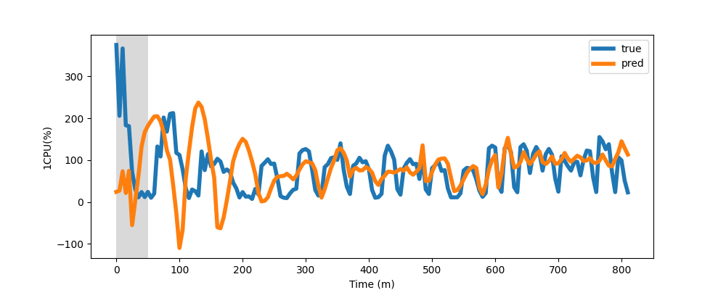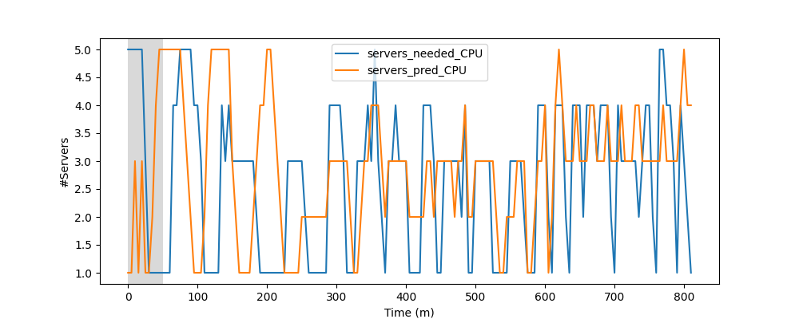

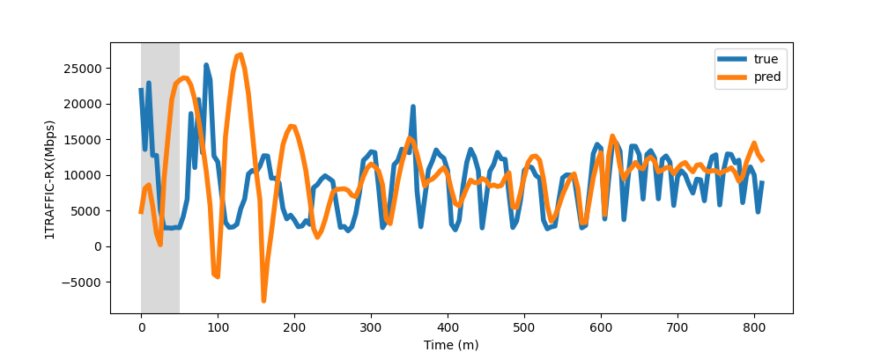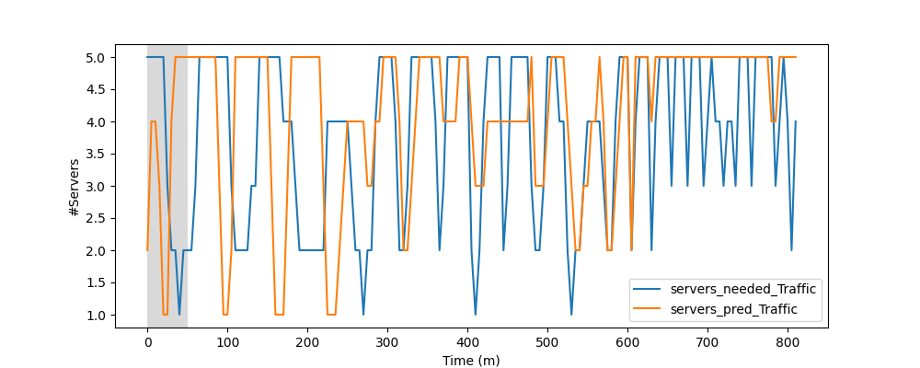

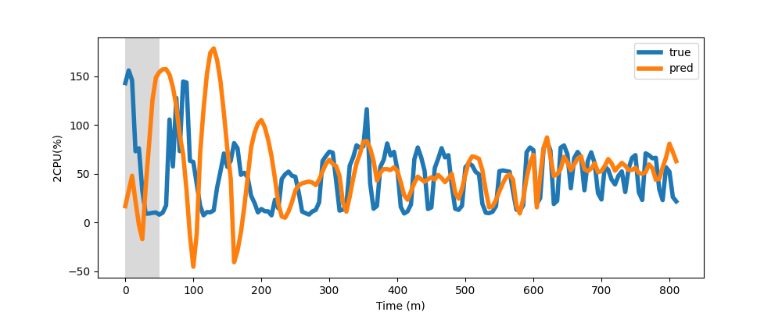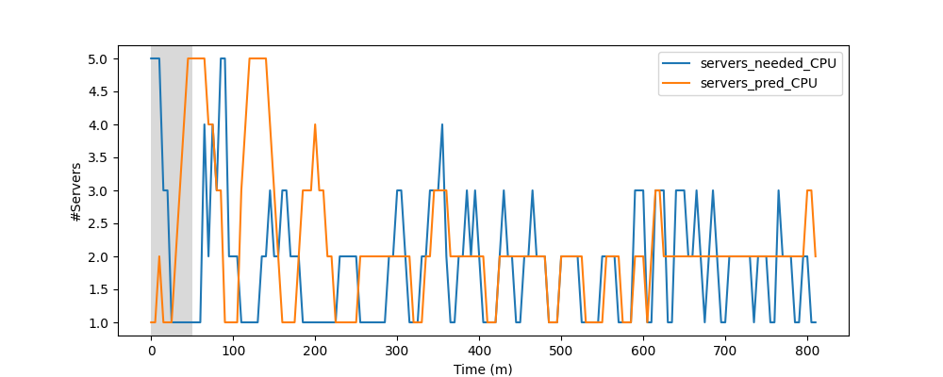

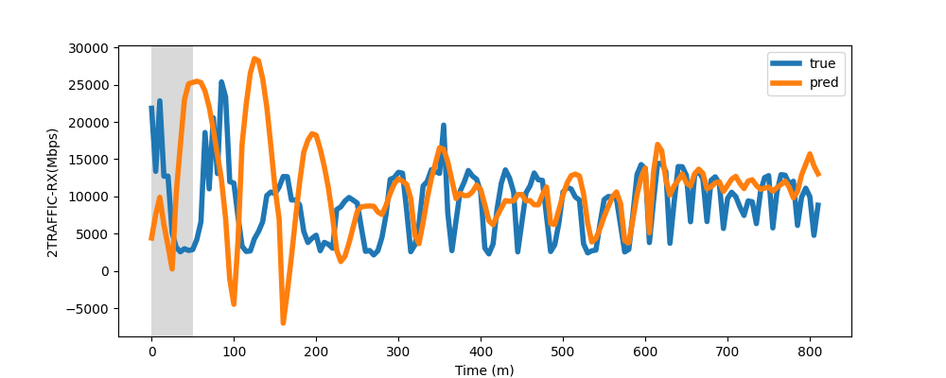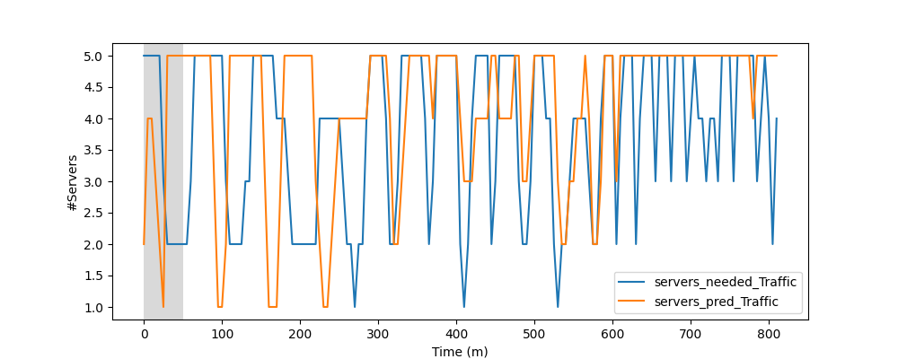

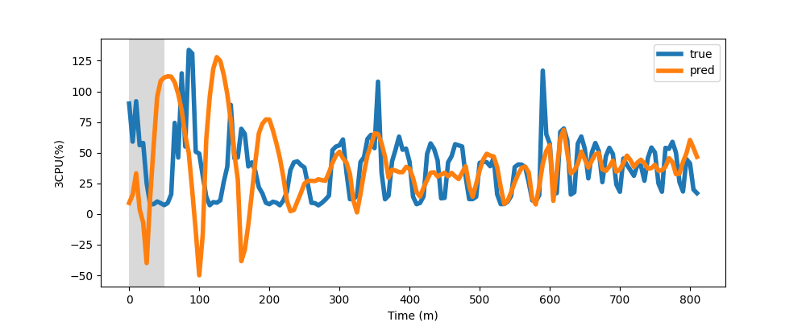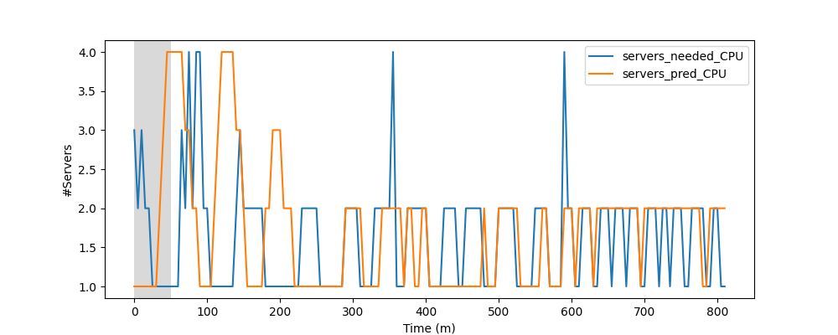

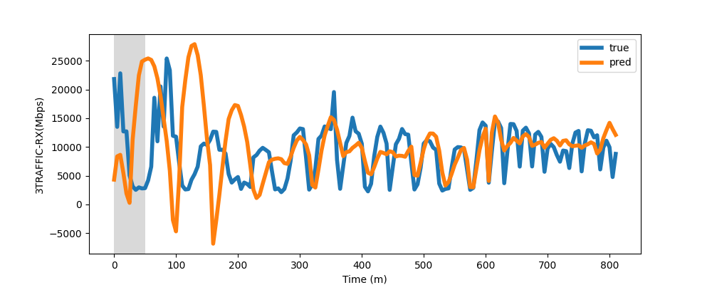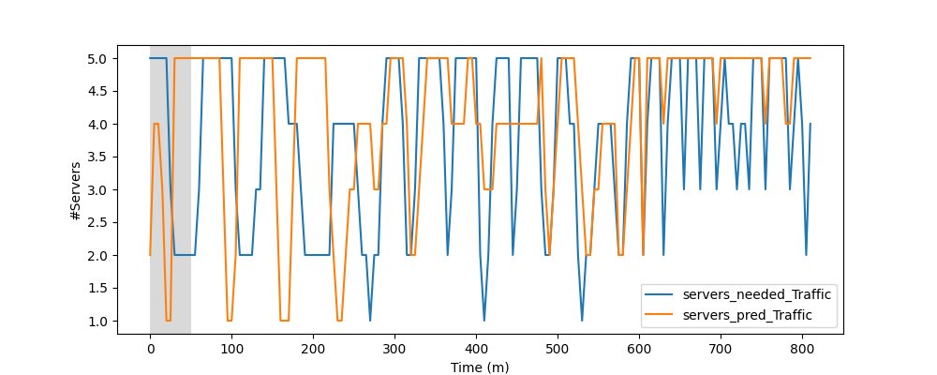

1. Warmup_steps = 60

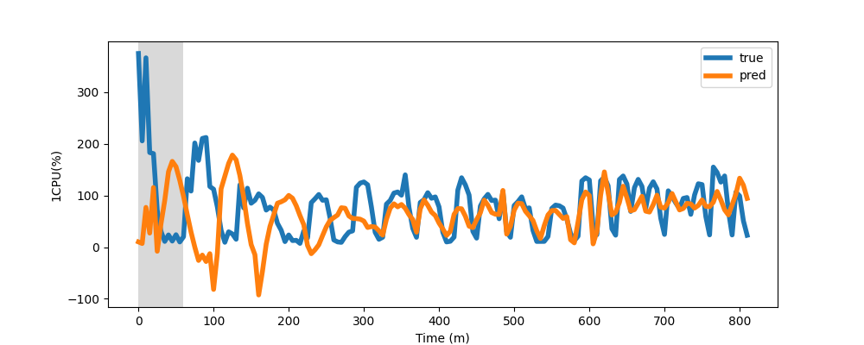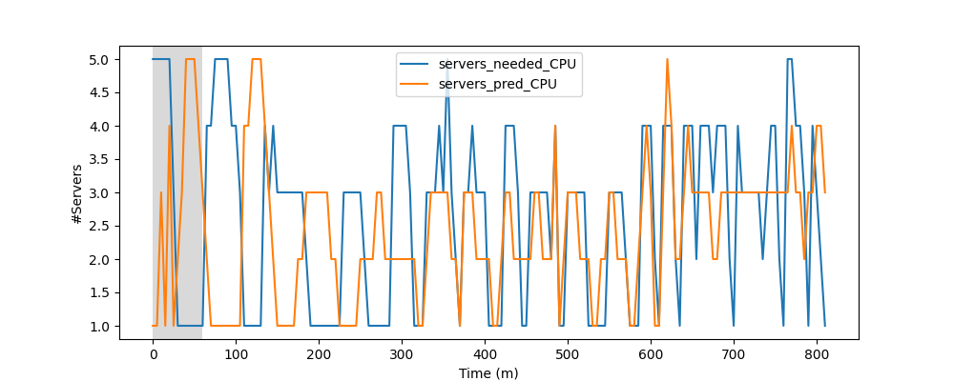

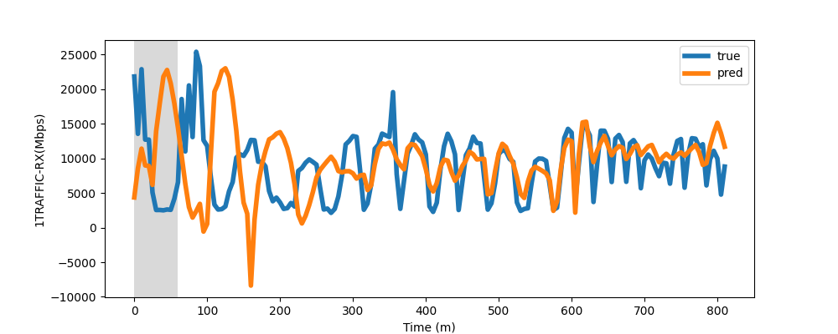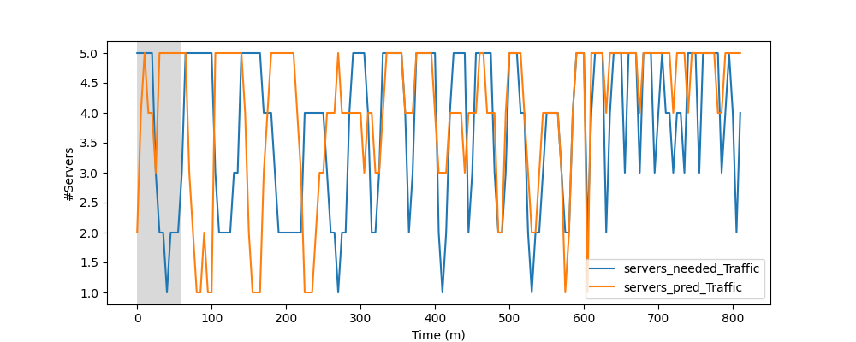

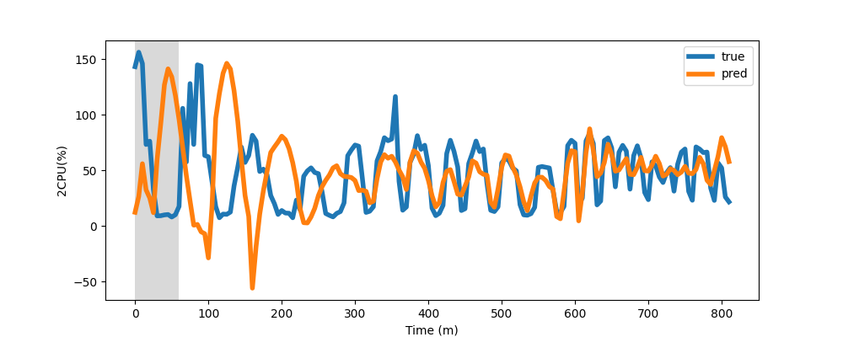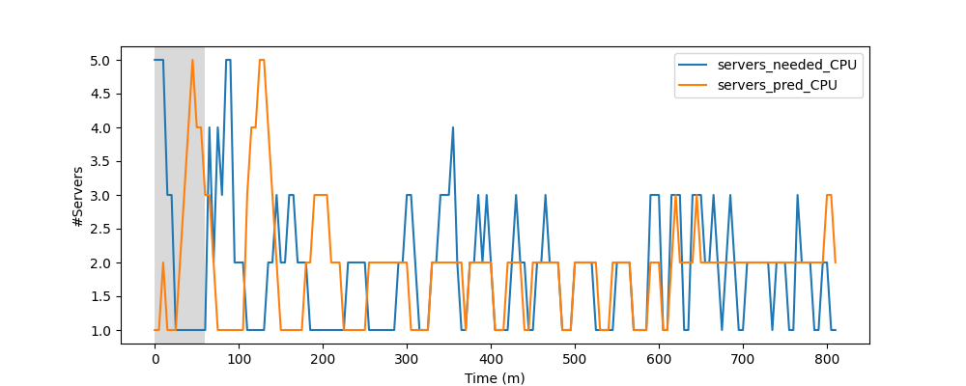

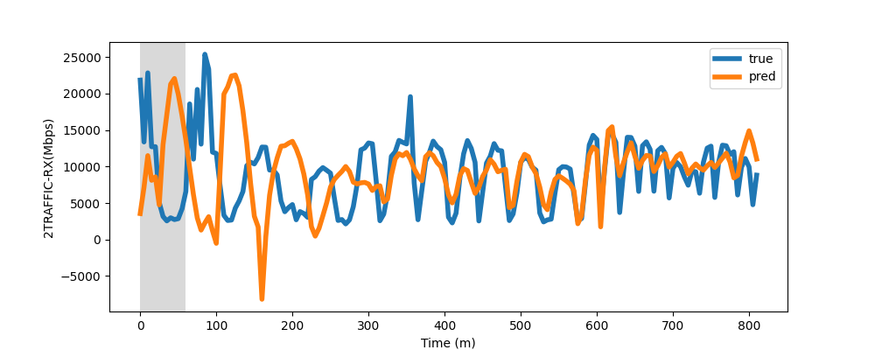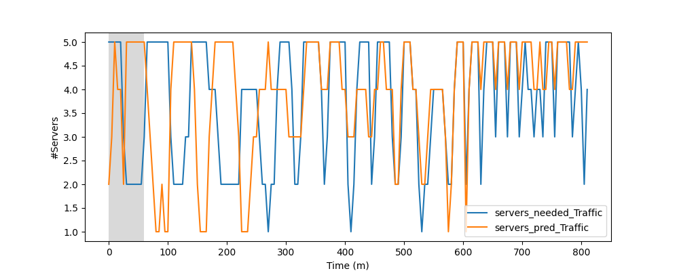

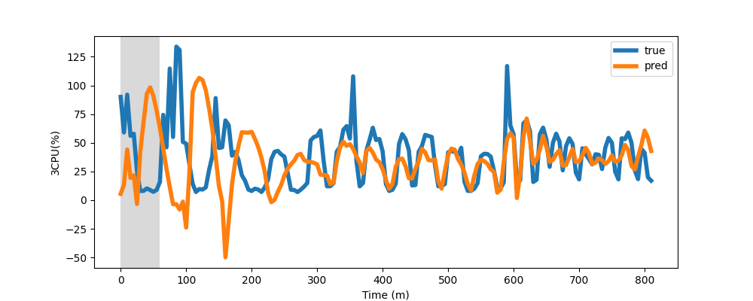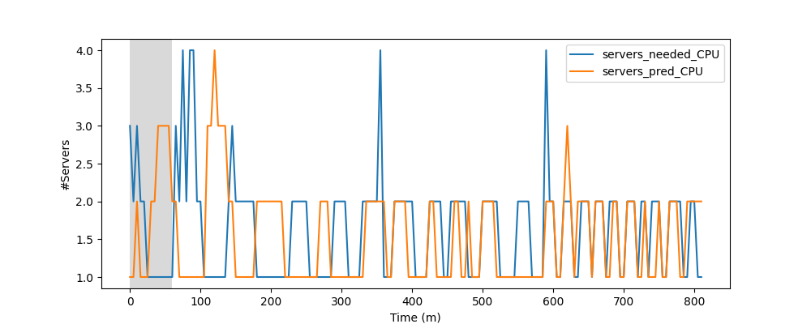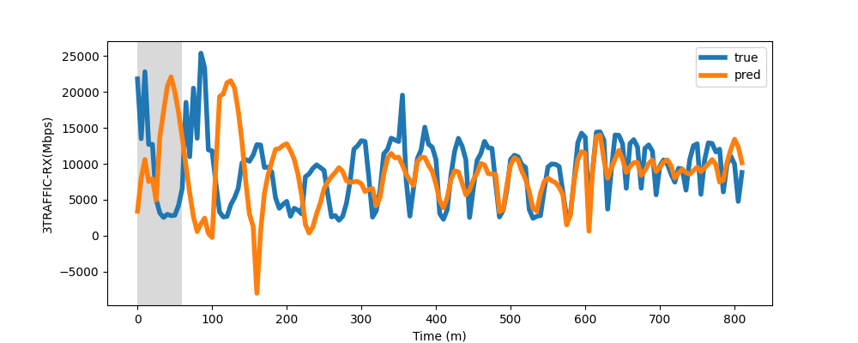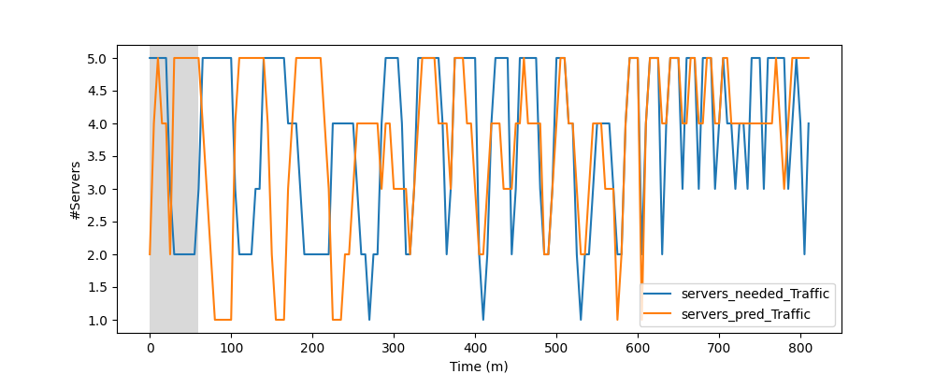

1. Warmup_steps = 70

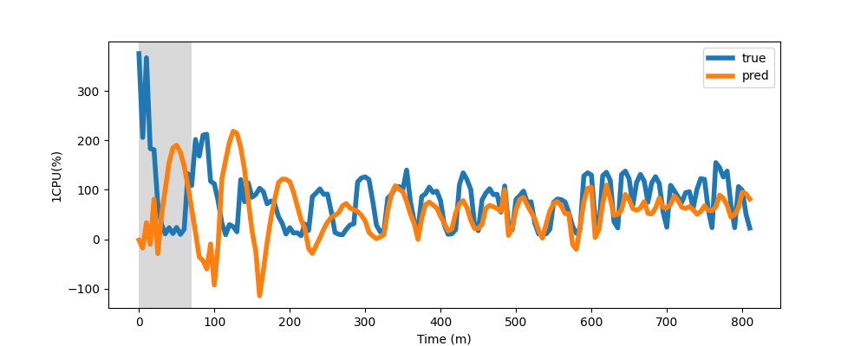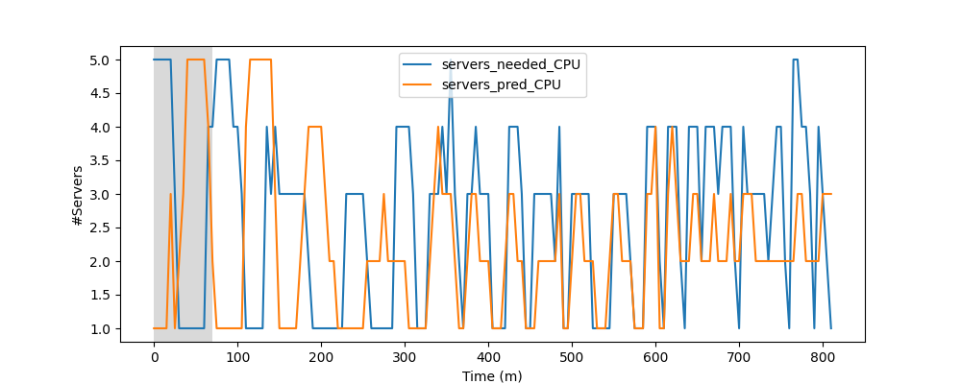

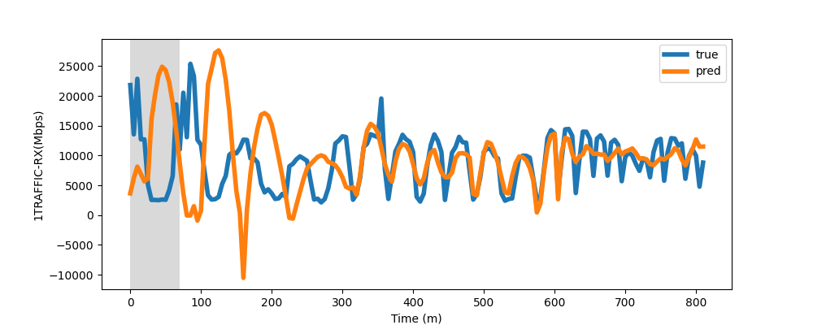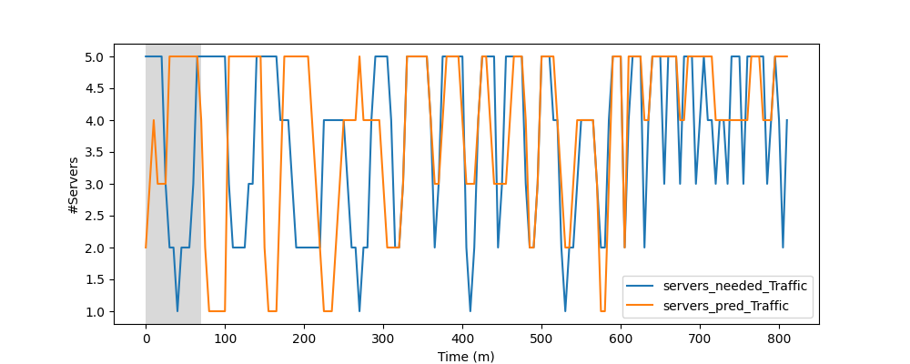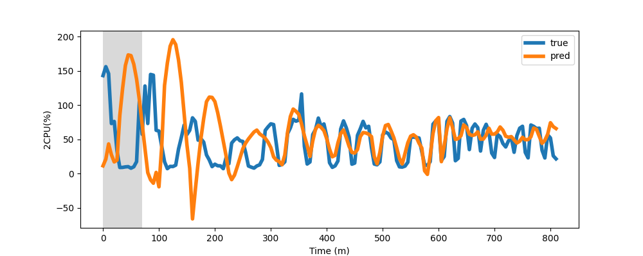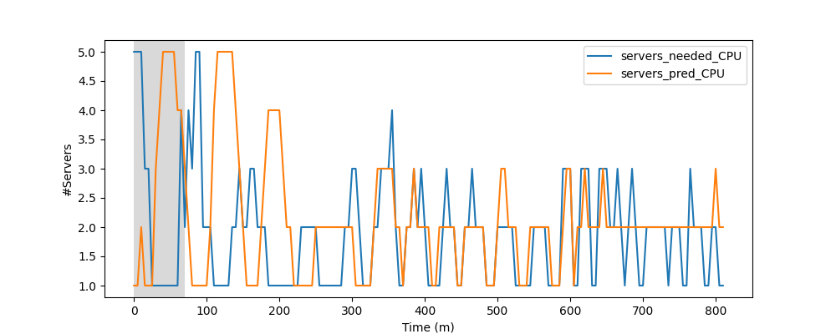

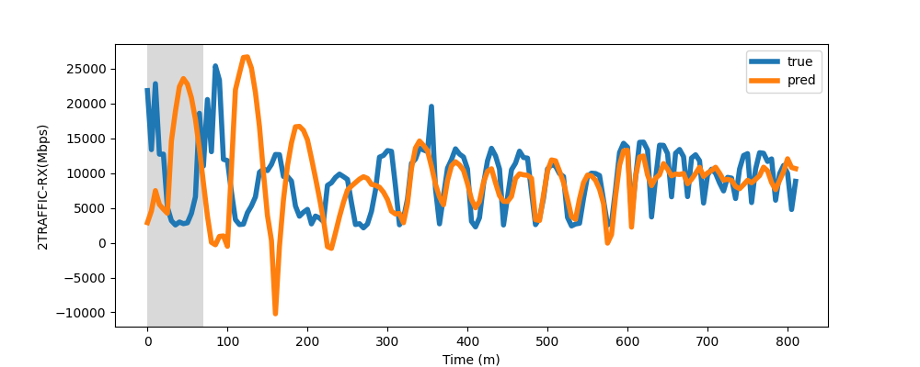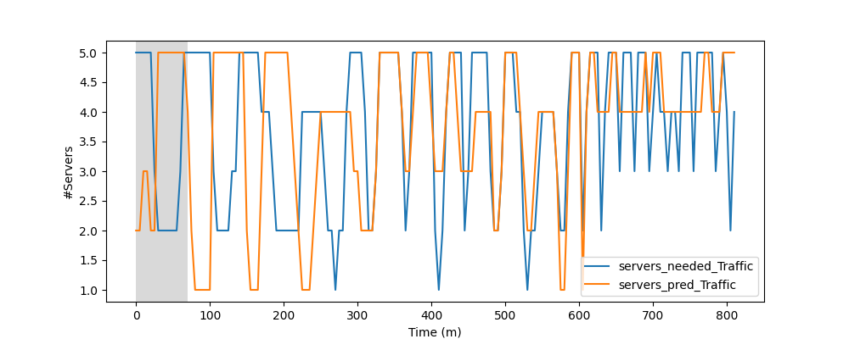

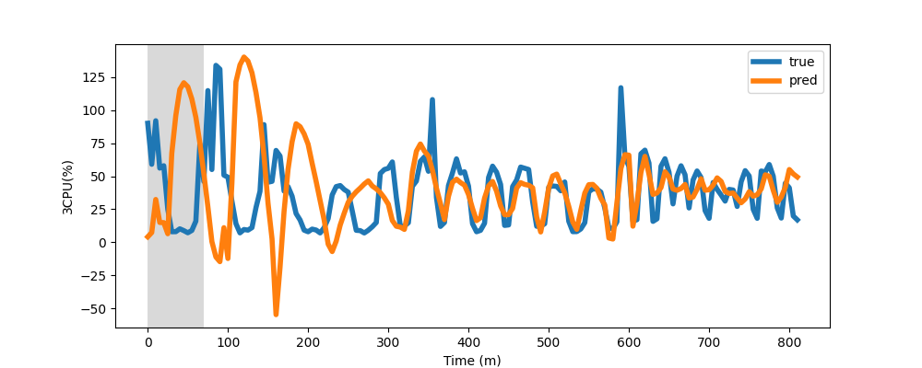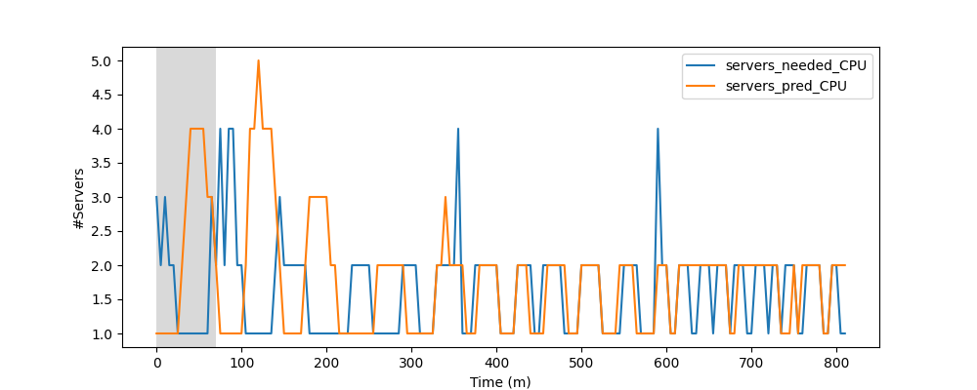

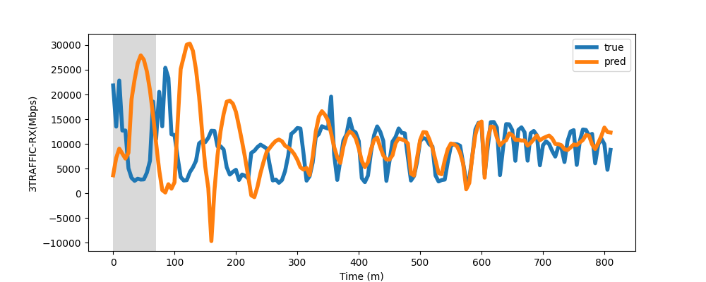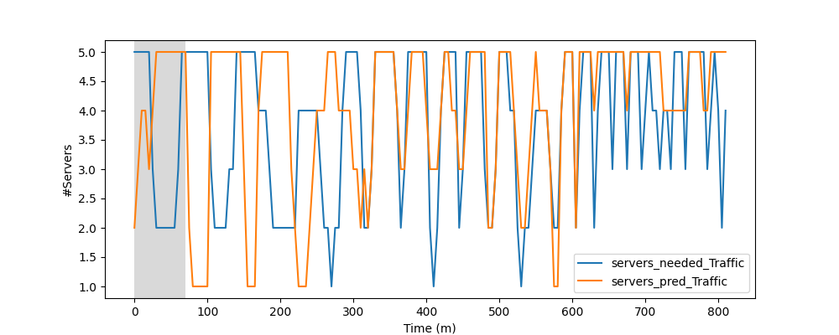

1. Warmup_steps = 80

